**MILK DAIRY MANAGEMENT SYSTEM**

Architectural diagrams.

1. Use Case Diagram

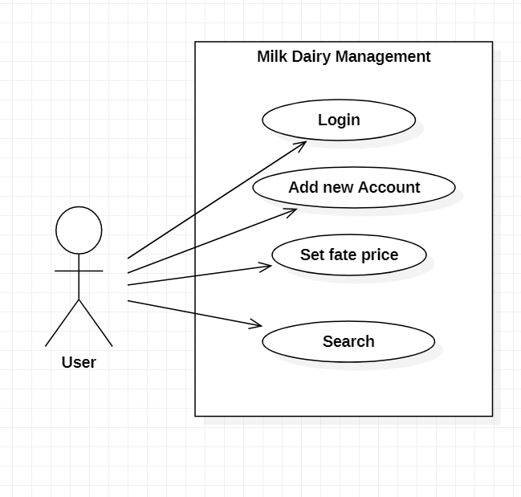

1. Entity Relationship Diagram.

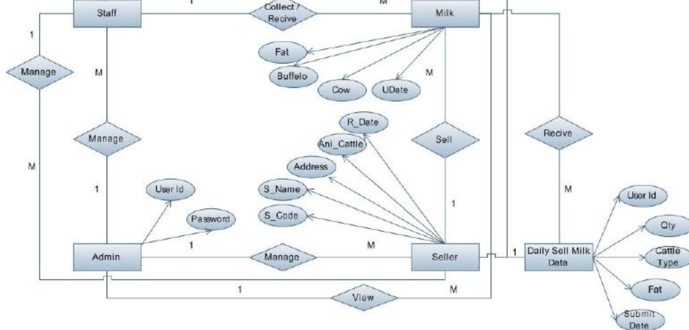

1. Activity Diagram.

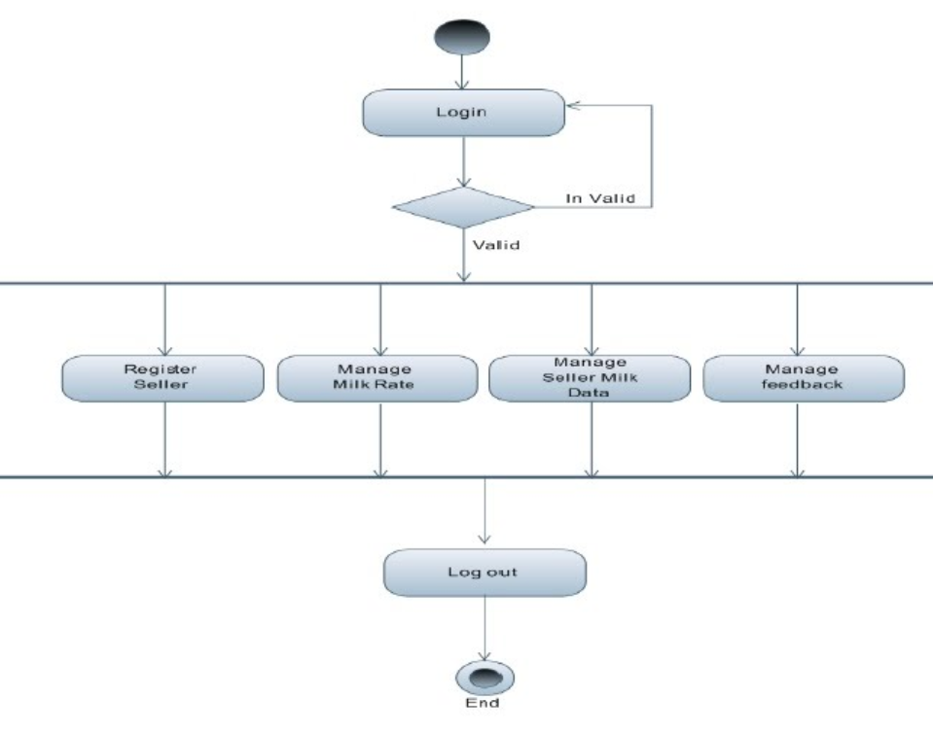

1. Figma Designs.

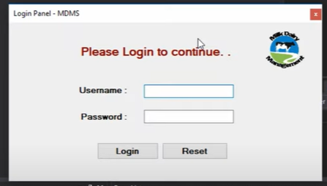

Log In Page

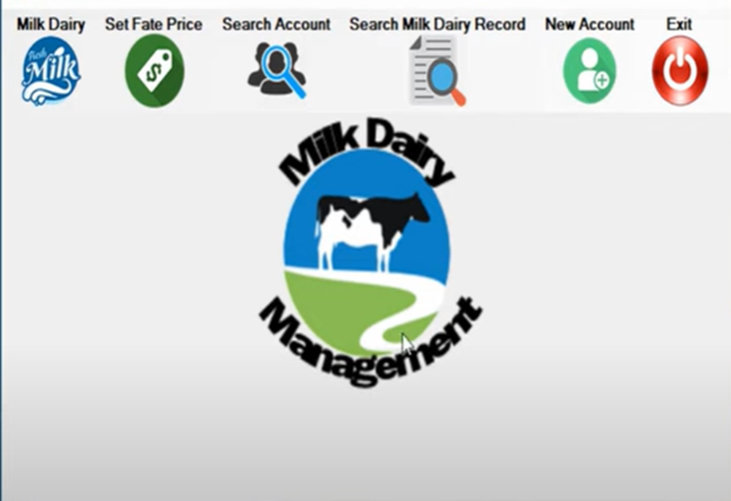

Dashboard.

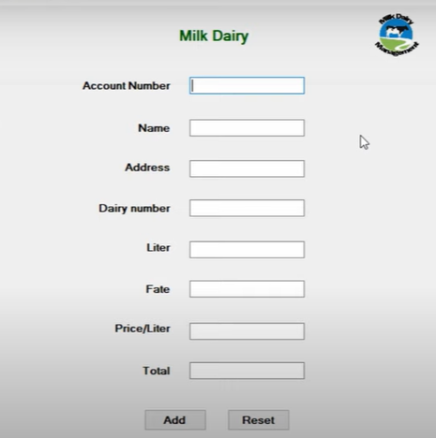

Add Account.

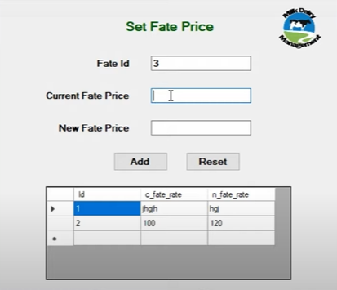

Set fate price.